Open ArcCatalog.

Open Layer Properties.

**If Layer has subtypes**: Update Default Values and Domains for **EACH** Subtypes**.**

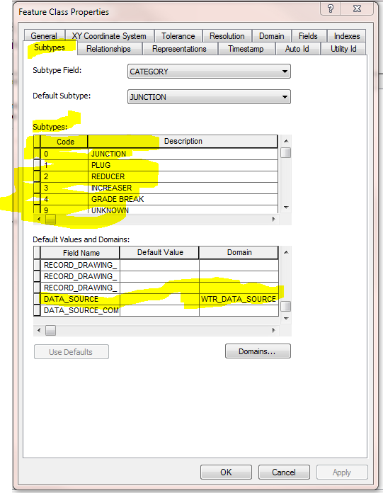

**If Layer doesn’t have subtypes:** 